REPORT OF THE 8TH AGBARHO BIBLE STUDENTS CLASS CONVENTION
A few of the invited brethren came. Those who came were Bro. John Isife from Ogun/Lagos, Bro. Godwin Edoja and Sr. Helen Edoja from Kwale, Bro. Chuks Edward from Onitsha and Bro. Vincent Aggreh and Sr. Silver Egodo from Warri; And Mercy Okalowe from Lagos.
The convention proper began with a welcome discourse titled “More than lip service” with emphasis on Exodus 20 verse and Matthew 7 verse 21. At 9.30 a.m. This set the mood for the study of the day titled “Make sure of winning in God’s election” from Reprint 3585. The study was a systematic examination of the requirements for participation in the election process, the procedure and the directives and encouragements from the Lord Jesus Christ and the Apostles, especially Paul, Peter, John and James. It was a well structured study that brought out a feeling of soberness in all the participants. The study covered the period 10.00 a.m. to 5.50 p.m. A testimony Meeting was held at 6.00 p.m. and the convention came to a close at 6.35 p.m. with our parting hymn 64.
The presence of Sr. Mercy Okalowe and her contributions were greatly appreciated by brethren. Her contributions actually inspired other sisters to make contributions too. In all, the convention was very rewarding gathering of the saints.
A group photograph was taken during the lunch break.
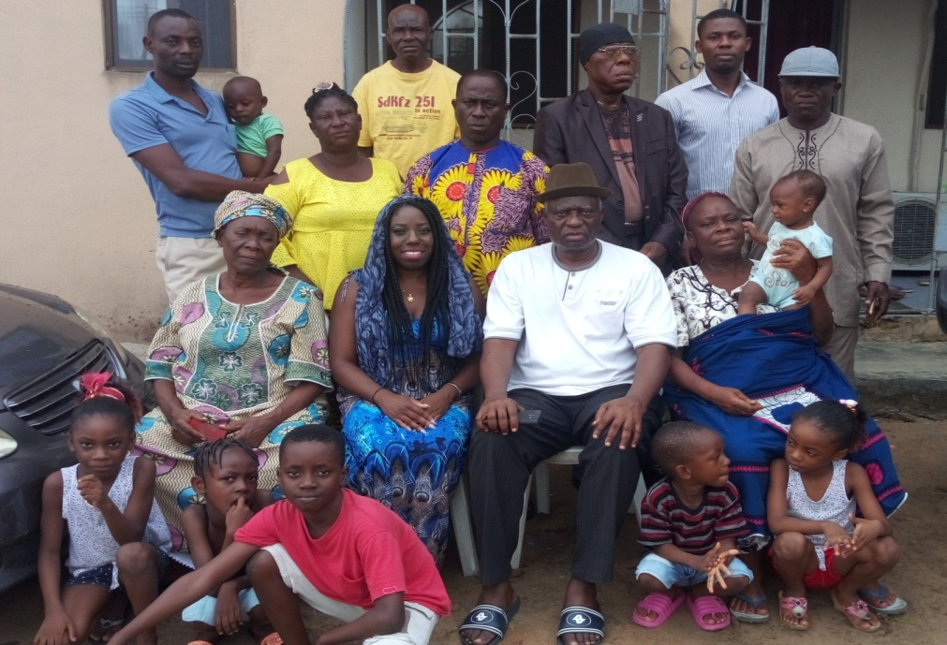
Bro. Moses Obire.
Agbarho Nov. 12, 2019

